Infosys Springboard Virtual Internship 6.0 Completion Report

Batch Number:
Start date : 10-11-2025
Names:
- BHAKTHI S P
- ARAVINDA
- CHARISHMA
- CHANNABASAVA
- SAKSHI

Internship Duration: 8 Weeks

1. Project Title
smart stock inventory optimization for retail store

2. Project Objective
The main objective of this project is to design and develop a smart inventory optimization system that helps retail stores efficiently manage their stock levels using data-driven techniques. The system aims to reduce overstocking and stock-out situations by accurately predicting product demand and optimizing reorder decisions.
Specifically, the project focuses on:
- Analyzing historical sales data to identify demand patterns and trends
- Forecasting future product demand using machine learning or statistical models
- Determining optimal reorder points and quantities to minimize holding and shortage costs
- Improving inventory turnover and overall store profitability
- Providing decision support to store managers through clear insights and reports

3. Project description in detail
The Smart Stock Inventory Optimization for Retail Store project focuses on developing an intelligent system that helps retail businesses manage their inventory efficiently by using data analytics and machine learning techniques. Traditional inventory management methods often rely on manual estimation or fixed reorder rules, which can lead to problems such as overstocking, stock shortages, increased storage costs, and loss of sales. This project aims to overcome these challenges by introducing a smart, automated, and data-driven inventory optimization solution.
The proposed system collects and analyzes historical sales data, product demand patterns, seasonal trends, and inventory movement records from the retail store. Based on this data, preprocessing techniques such as data cleaning, normalization, and trend analysis are applied to ensure accuracy and reliability. The system then uses demand forecasting models (such as time-series analysis or machine learning algorithms) to predict future product demand for different items.
Using the predicted demand, the system calculates optimal stock levels, reorder points, and reorder quantities for each product. This ensures that sufficient inventory is available to meet customer demand while minimizing excess stock and holding costs. The system can also consider factors such as lead time, supplier reliability, safety stock, and sales variability to make more accurate inventory decisions.
.
4. Timeline Overview
Week | Activities Planned | Activities Completed
Week 1 | Problem identification, requirement analysis, and literature survey on inventory optimization | Identified inventory challenges in retail stores and completed literature survey
Week 2 | Data collection planning and dataset identification (sales, stock, demand data) | Identified sample retail dataset and finalized data attributes
Week 3 | Data preprocessing design (cleaning, normalization, handling missing values) | Cleaned dataset and performed data preprocessing
Week 4 | Exploratory data analysis and demand pattern identification | Analyzed sales trends, seasonal patterns, and product movement
Week 5 | Design of demand forecasting model and inventory optimization logic | Implemented basic forecasting model and reorder point calculation
Week 6 | System implementation and integration of inventory optimization module | Integrated forecasting with inventory decision rules
Week 7 | Testing, performance evaluation, and result analysis | Tested system accuracy and evaluated inventory optimization results
Week 8 | Documentation, report preparation, and presentation design | Completed project report and prepared seminar presentation

5a. Key Milestones
Milestone | Description | Date Achieved
Project Kickoff | Project initiated by defining objectives, scope, system requirements, and inventory optimization goals for a retail store. | 10 – nov – 2025
Prototype / First Draft | Developed an initial prototype including sales data analysis, basic demand forecasting, and stock level optimization logic. | 28 – nov – 2025
Mid-Term Review | Conducted mid-term evaluation to review forecasting accuracy, inventory decisions, and system performance; refined the approach. | 11 – dec – 2025
Final Submission | Completed and submitted the Smart Stock Inventory Optimization system with full functionality, results, and documentation. | 26 – dec– 2025
Presentation | Prepared and delivered the final project presentation highlighting system architecture, features, results, and benefits. | 10 – jan – 2025

5b. Project execution detail

.
- Requirement Analysis – Identified retail inventory challenges, gathered user requirements from store managers, defined system scope, and finalized project objectives such as demand forecasting and stock optimization.
- Technology Selection – Selected Python for backend processing, machine learning models (ARIMA, LSTM) for demand forecasting, SQL for inventory database management, and a web-based dashboard (React/HTML/CSS) for user interaction.
- System Design – Designed the overall system architecture, database schema for products and sales, workflow diagrams, and user interface mockups for inventory monitoring and alerts.
- Data Collection – Collected historical sales, stock, and transaction data from retail datasets; generated dummy data to simulate multiple products and seasonal demand.
- Data Preprocessing – Cleaned raw data by handling missing values and outliers, categorized products, normalized sales data, and structured datasets for model training.
- Model Development – Developed and trained demand forecasting models, evaluated prediction accuracy, and implemented logic for optimal reorder points, safety stock, and inventory levels.
- Frontend Development – Created interactive dashboards displaying current stock levels, demand forecasts, low-stock alerts, and sales trends using charts and reports.
- Backend Development – Implemented APIs for data flow between the database, forecasting models, and user interface; integrated inventory optimization logic with real-time updates.
- Testing & Integration – Performed unit testing, system testing, and user acceptance testing to ensure accurate forecasts, reliable stock alerts, and smooth system operation.
- Deployment & Documentation – Deployed the system on a local server or cloud platform, prepared technical and user documentation, and demonstrated the final system during project presentation.

6. Snapshots / Screenshots
Step 1 : Analyzing the current inventory condition using visual dashboards. By categorizing products into optimal, understock, and overstock, the system provides a clear snapshot of inventory health and helps retail managers take timely corrective actions.
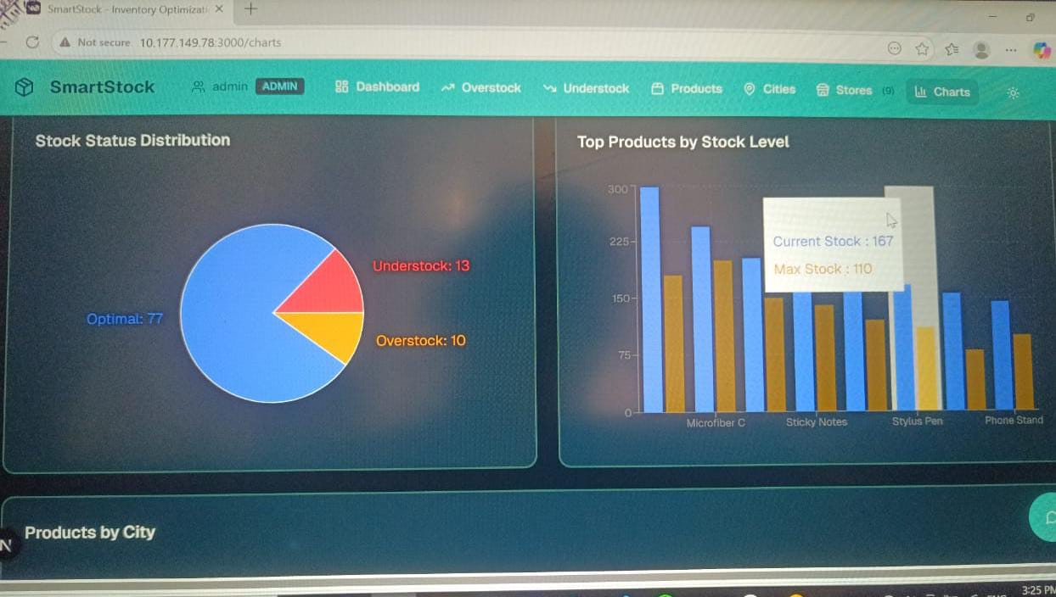
Step 2 : Shows the Analytics & Reports dashboard, which provides a real-time summary of inventory performance across all cities and stores.
- Total Products (100): Total number of products monitored in the system.
- Understock Items (13): Products below minimum stock level, requiring immediate replenishment to avoid stock-outs.
- Overstock Items (10): Products exceeding optimal stock limits, suggesting the need for promotions or redistribution.
- Optimal Stock (77): Products maintained at healthy stock levels, indicating efficient inventory management.

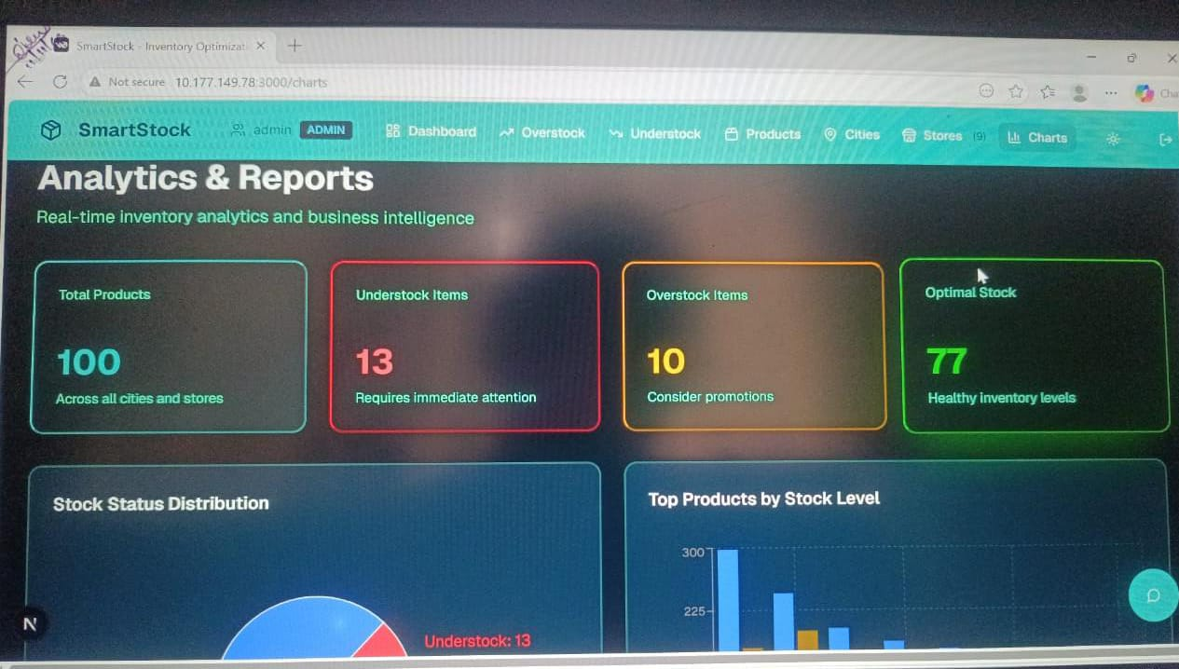

Step 3: Represents the Store Management module of the SmartStock system, used to manage retail store locations and their inventory data.
- Total Stores (9): Shows the number of active retail store locations in the system.
- Total Products (609): Total product entries across all stores.
- Average per Store (68): Average number of products maintained in each store.
The search bar allows users to quickly find stores by store name, city, or manager, improving navigation and control.
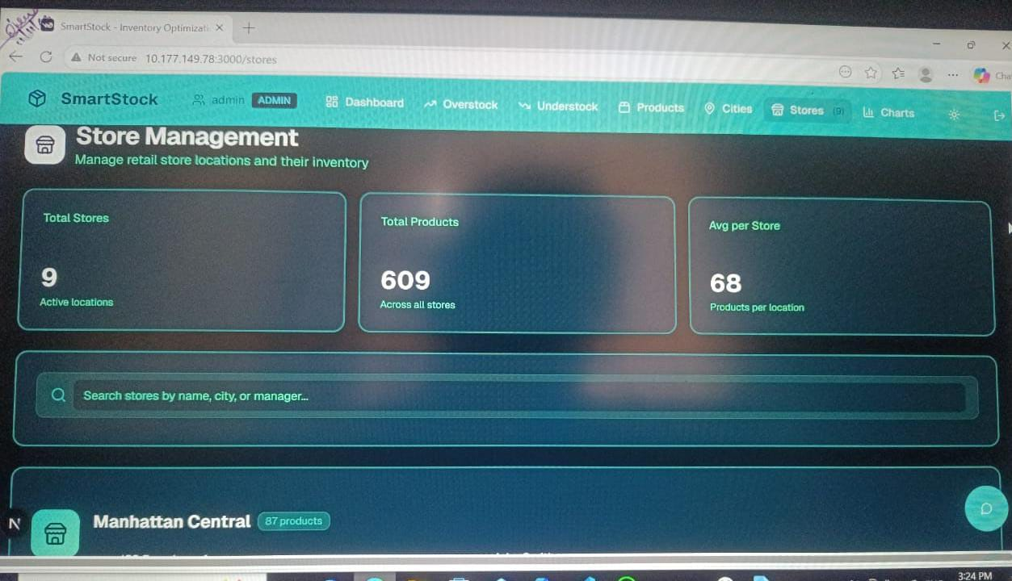
Step 4:Shows the Cities & Locations module of the SmartStock system, which focuses on inventory distribution across different cities and retail locations.
- Total Cities (15): Number of cities where the retail stores are operating.
- Retail Stores (86): Total stores distributed across all cities.
- Total Products (2564): Overall product count across every location.
- Total Inventory Value ($1335K): Combined monetary value of inventory across all cities.
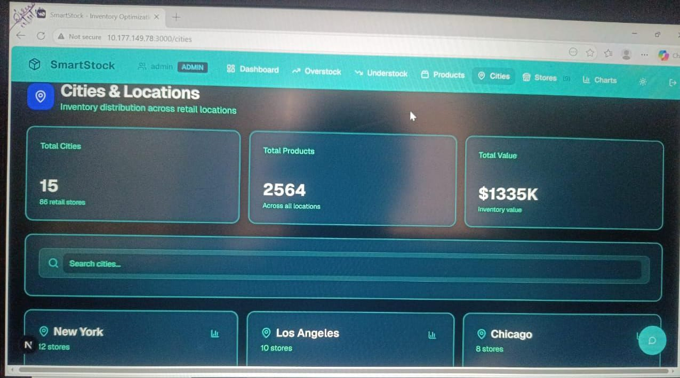
Step 5: Each row represents an individual product with key details:
- Product Name & SKU: Unique identification of each item.
- Category: Product classification (Accessories, Cleaning, Office, etc.).
- Stock (Current / Threshold): Shows available quantity compared with the recommended limit.
- Status: Indicates inventory condition (here, products are marked as Overstock).
- City: Location where the product is stored.
- Price: Selling price of the product.
- Actions: Options to edit or manage product details.


Step 6: The Products page of the SmartStock inventory optimization system, where product-level stock details are monitored and managed.
- Search Bar: Enables quick searching of products using name, SKU, or category.
- Product List Table: Displays detailed information for each item:
  - Product Name & SKU: Unique identifiers for accurate tracking.
  - Category: Classifies products (Accessories, Cleaning, Office).
  - Stock (Current / Threshold): Shows current quantity compared with the predefined stock limit.
  - Status: Highlights inventory condition (all listed items are marked Overstock).
  - City: Indicates the store location holding the product.
  - Price: Retail selling price of the item.
  - Actions: Options to edit or update product information.

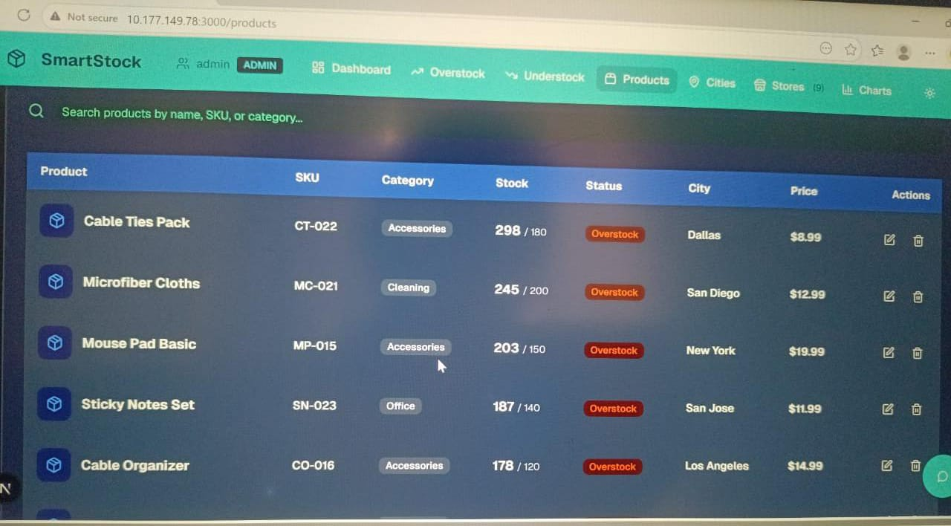

Step 7: This image shows the Products section of the SmartStock inventory optimization system, which provides detailed tracking of individual products across stores.
- Products are listed with Name, SKU, Category, Stock level, Status, City, and Price.
- The Stock column compares current quantity with the allowed limit (e.g., 298 / 180).
- The Status column highlights inventory condition; here, all shown items are marked Overstock, indicating excess quantity.
- City shows where each product is currently stored.
- Action icons allow editing or managing product details.
- The search bar helps quickly find products by name, SKU, or category.
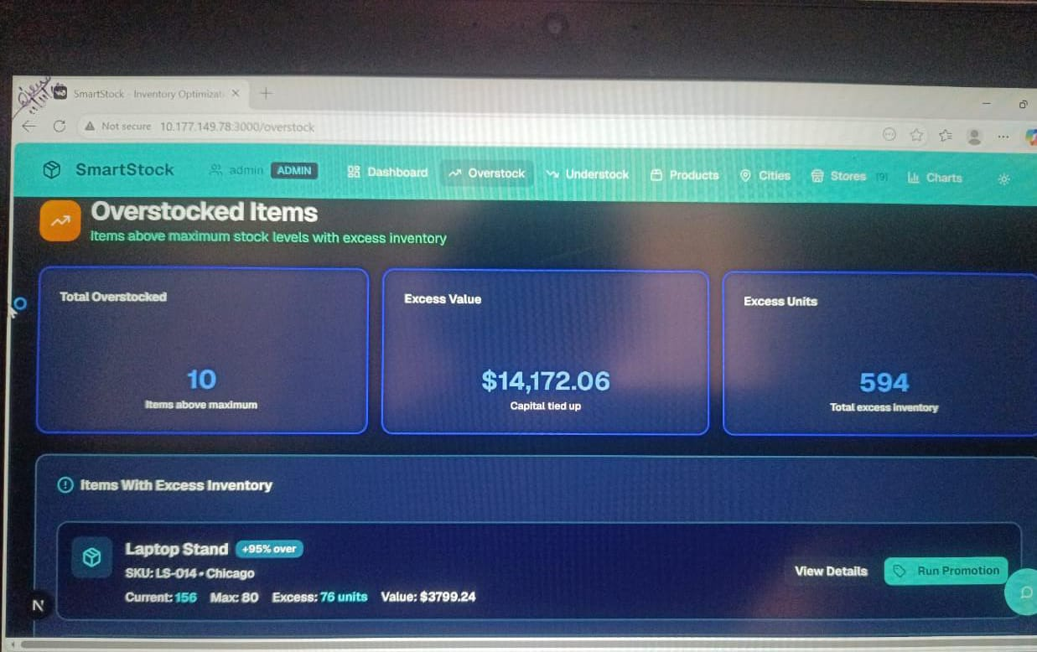

Step 8: Final one,
This screen is part of an inventory management web application called SmartStock, specifically the Products section.
Top Navigation Bar
- User Role: Admin (ADMIN)
- Main Tabs:
  - Dashboard
  - Overstock
  - Understock
  - Products (currently selected)
  - Cities
  - Stores (9)
  - Charts

Search Bar
- Allows searching products by name, SKU, or category
Products Table Details
Column | Description
Product | Name of the product
SKU | Unique Stock Keeping Unit ID
Category | Product category
Stock | Current stock / Threshold limit
Status | Inventory condition (Overstock)
City | Location of inventory
Price | Product price
Actions | Edit / Delete icons

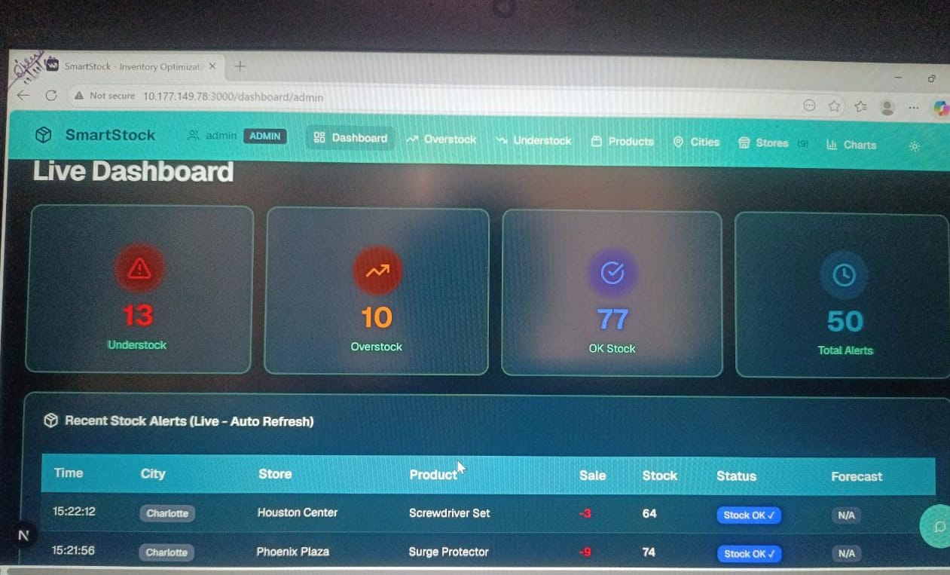

7. Challenges Faced
Below is the rewritten and adapted content for the project
“Smart Stock Inventory Optimization for Retail Store”, covering 7. Challenges Faced and 8. Learnings & Skills Acquired, written in a professional, report-ready format.

- Data Availability – Accessing real-world retail inventory and sales datasets was challenging, leading to reliance on simulated or publicly available datasets.
- Data Quality Issues – Sales and stock data contained missing values, inconsistencies, and noise, requiring extensive data cleaning and preprocessing.
- Demand Forecasting Accuracy – Achieving accurate demand predictions was difficult due to seasonal variations, sudden demand spikes, and changing customer behavior.
- Algorithm Selection – Selecting the most suitable forecasting model (ARIMA, LSTM, Regression) required multiple experiments and performance comparisons.
- Integration Complexity – Integrating forecasting models with the backend system, inventory database, and frontend dashboard caused synchronization and data flow challenges.
- Real-Time Inventory Updates – Ensuring timely stock updates and low-latency alerts without impacting system performance was a significant challenge.
- User Interface Design – Designing a simple yet informative dashboard for store managers, balancing usability with detailed inventory insights, required several iterations.
- Security Concerns – Ensuring secure storage of sales and inventory data, along with protected access to the system, was critical.
- Time Management – Completing data preparation, model development, system integration, testing, and documentation within the 8-week timeline was demanding.
- Testing & Validation – Validating system performance across multiple products, demand patterns, and stock scenarios required extensive testing.

8. Learnings & Skills Acquired
Here is the adapted and project-specific version of “8. Learnings & Skills Acquired” for
Smart Stock Inventory Optimization for Retail Store

8. Learnings & Skills Acquired
- AI & Machine Learning Knowledge – Gained practical experience in applying forecasting algorithms such as ARIMA, LSTM, and regression models for retail demand prediction.
- Data Handling Skills – Improved ability to collect, clean, preprocess, and analyze large-scale retail sales and inventory datasets.
- Time-Series Analysis – Learned techniques for identifying trends, seasonality, and demand patterns from historical sales data.
- Inventory Management Concepts – Developed a strong understanding of stock optimization, reorder points, safety stock, and inventory turnover.
- Full-Stack Development – Enhanced skills in backend development (Python, Flask/Django), frontend interfaces (React.js/HTML/CSS), and database integration (MySQL/PostgreSQL).
- Visualization & Reporting – Built interactive dashboards using Matplotlib, Plotly, or similar tools to visualize stock levels, forecasts, and alerts.
- Problem-Solving Abilities – Addressed challenges such as inconsistent data, demand variability, model tuning, and system integration.
- Cloud & Deployment Skills – Learned to deploy inventory optimization systems on cloud or local servers for real-time accessibility.
- Collaboration & Teamwork – Strengthened teamwork and project coordination through Agile practices, task allocation, and regular progress reviews.
- Testing & Validation – Gained experience in unit testing, system testing, and validating forecasting accuracy across multiple products and scenarios

9. Testimonials from team
Team Member 1:
"This project enhanced my understanding of demand forecasting and inventory optimization techniques, and helped me apply machine learning models to analyze real-world retail sales data."
Team Member 2:
"I gained hands-on experience in data preprocessing, stock level analysis, and building interactive dashboards for inventory monitoring, which strengthened my technical and analytical skills."
Team Member 3:
"Working on this project taught me effective teamwork, project planning, and how to integrate machine learning models with backend systems for a practical retail application."
Team Member 4:
"The project improved my knowledge of inventory management concepts, forecasting algorithms, and data visualization techniques, and boosted my confidence in developing real-world data-driven solutions."

10. Conclusion

The Smart Stock Inventory Optimization for Retail Store project successfully demonstrates how data-driven and intelligent techniques can improve traditional inventory management systems. By analyzing historical sales and stock data, the system accurately forecasts product demand and determines optimal stock levels, reorder points, and safety stock. This helps retail stores reduce issues such as overstocking, stock-outs, and unnecessary holding costs.

11. Acknowledgements
Thank the organization, mentor, and any team members who supported your internship journey.
I would like to express my sincere gratitude to Infosys for providing me the opportunity to work on the Smart Stock Inventory Optimization for Retail Store and gain hands-on experience in AI and ML applications.
I am especially thankful to my mentor, Shakthi Gopalakrishnan, for their constant guidance, support, and valuable insights throughout the internship. Their mentorship helped me overcome challenges and grow both technically and professionally.
I would also like to thank my team members for their collaboration, encouragement, and efforts in successfully executing this project. Their teamwork made the internship journey smooth and enriching.
Finally, I appreciate everyone who contributed directly or indirectly to my learning and the completion of this project.

